**Numerical Method Note**

Linear:

1. Errors and measure of errors.
2. Root finding - open and closed

- Bisection, Flase position.

- Iteration method(one point iteration/open), Newton Raphson, Secant

Non-Linear:

1. Interpolation

- Forward, backward, central, divided difference, lagrange interpolation, inverse interpolation.

1. Curve fittting(Linear and Non-Linear)

- Least quare, Staright line, Polinomial, Exponential, Linera weighted LS.

1. Gausian Elemination

- Gauss jordan, Jacobian, Seeeding.

1. Intigation

- Trapizoidal, simpson 1/3, romberg,

1. Differentiation

- Tailor, pickard, eular modified rule, eular method.

Rules for Identifying Significant Figures

* Nonzero digits are always significant.
* Example: 456 → 3 significant figures
* Zeros between nonzero digits are significant.
* Example: 4056 → 4 significant figures
* Leading zeros (before nonzero digits) are NOT significant.
* Example: 0.0042 → 2 significant figures (only "42" counts)
* Trailing zeros after a decimal point are significant.
* Example: 4.200 → 4 significant figures
* Trailing zeros in whole numbers without a decimal are NOT significant (unless stated with a decimal or scientific notation).
* Example: 7000 → 1 significant figure (unless written as 7.00 × 10³, which has 3)

Both the Bisection Method and the False Position Method are reliable root-finding techniques that guarantee convergence, the False Position Method is generally more efficient and faster than the Bisection Method, especially for functions that are approximately linear or well-behaved(can determine derivative).

However, for highly nonlinear functions, the Bisection Method might sometimes perform better, as the False Position Method may face issues with fixing one endpoint.

Newton-Raphson Method generally has quadratic convergence. If you need to find the square root of a number, the Newton-Raphson method converges very quickly. When derivative is bigger it need a few iteration. But for zero derivate It cann’t determine root.

The Newton-Raphson Method, on the other hand, does not require such an interval. It starts from an initial guess and refines the estimate of the root based on the function.

The Newton-Raphson Method can be adapted to find multiple roots.

Bisection Method has linear convergence—it reduces the error by a constant factor with each iteration.

False Position Method also has linear convergence, but might converge slightly faster than the Bisection Method for certain functions.

Secant Method is a popular root-finding algorithm that combines the best aspects of both the Bisection Method and the Newton-Raphson Method. The Secant Method is a good option for nonlinear functions where finding derivatives analytically may be challenging or cumbersome.

**Math Example Link:[1]**

Let f(x) be a continuous function. The secant method is a variant of Newton's method that avoids the use of the derivative of f(x), which can be very helpful when dealing with the derivative is not easy. there are certain functions whose derivatives may be extremely difficult or impossible to determine. [2]

It avoids the use of the derivative by approximating

  f′(x) by f(x+h)−f(x)/h for some h.

To limit the number of evaluations of f(x) required, it uses x = xn−1 and x+h = xn.

Here is how it works.

Suppose that we have already found xn. Then we denote by y = F(x) the equation of the (secant) line that passes through (xn−1,f(xn−1)) and (xn,f(xn)) and we choose xn+1 to be the value of x where F(x)=0.

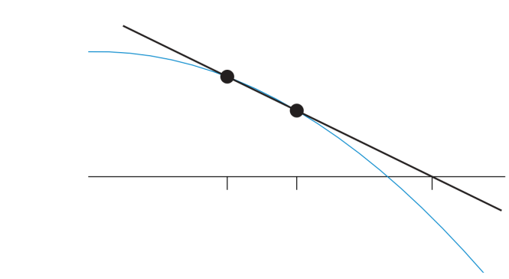

The equation of the secant line is

Y = F(x) = f(xn−1) + f(xn)−f(xn−1)(x−xn−1)/xn−xn−1

so that xn+1 is determined by

0 = F(xn+1) = f(xn−1) + f(xn)−f(xn−1)(xn+1−xn−1)/xn−xn−1

⟺ xn+1 = xn−1 − xn−xn−1 f(xn−1) / f(xn)−f(xn−1) or, simplifying,

Secant method.

xn+1 = xn −f(xn)(xn − xn−1)/f(xn)−f(xn−1)

Of course, to get started with n = 1, we need two initial guesses, x0 and x1, for the root. Find points x0and x1 such that x0<x1 and f(x0).f(x1)<0.

Gauss elimination method-

* Direct: Gauss Jordan
* Iterative: Jacobi, Seidal [3][4]

Augmented matrix is a way of representing a system of linear equations in matrix form, where the coefficients of the variables and the constants are combined into a single matrix. It is used in solving systems of equations using methods like Gauss Elimination or Gauss-Jordan Elimination.

Gauss-Jordan Elimination Method is an extension of the Gauss Elimination Method. It is used to solve a system of linear equations by reducing the augmented matrix to its reduced row-echelon form (RREF). This method eliminates all entries both below and above the main diagonal, leaving a diagonal matrix with 1s on the diagonal that is identity matrix.

Diagonally dominant matrix is a square matrix where, for every row, the absolute value of the diagonal element is greater than the sum of the absolute values of the non-diagonal elements in that row.

The main difference between the Jacobi and Gauss-Seidel methods is how the variables are updated during each iteration:

* Jacobi Method: All variables are updated simultaneously using the old values from the previous iteration.
* Gauss-Seidel Method: Variables are updated sequentially, and each updated variable is used immediately in the current iteration.

1. <https://atozmath.com/example/CONM/NumeInterPola.aspx?q=F&q1=E1>
2. [https://math.libretexts.org/Bookshelves/Calculus/CLP-1_Differential_Calculus_(Feldman_Rechnitzer_and_Yeager)/06%3A_Appendix/6.03%3A_C-](https://math.libretexts.org/Bookshelves/Calculus/CLP-1_Differential_Calculus_(Feldman_Rechnitzer_and_Yeager)/06%3A_Appendix/6.03%3A_C-_Root_Finding/6.3.04%3A_C.4_The_secant_method)

   [_Root_Finding/6.3.04%3A_C.4_The_secant_method](https://math.libretexts.org/Bookshelves/Calculus/CLP-1_Differential_Calculus_(Feldman_Rechnitzer_and_Yeager)/06%3A_Appendix/6.03%3A_C-_Root_Finding/6.3.04%3A_C.4_The_secant_method)
3. <https://atozmath.com/example/conm/GaussEli.aspx?q=GJ2&q1=E1>
4.